Week 2

The aim of this examples paper is to familiarise yourself with Visual Studio (2019 or 2022). At the end of the session, you must be able to create a simple (console-based) C++ application, compile, debug and execute that within your IDE environment.

- When opening Visual Studio chose “Create a new project” as shown here:
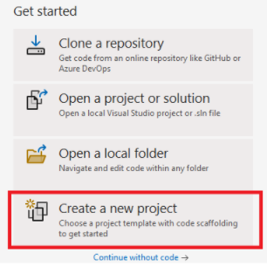

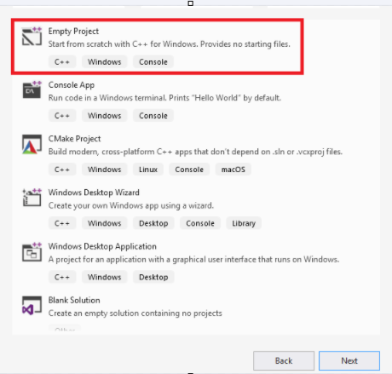
Then choose an “Empty Project”

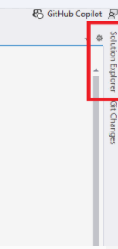
After creating the project, click on the “solution Explorer”. Usually, it is at the very end to the right of the screen:

Right click on “Source Files” as shown below, then Choose “New Item”. That will create a new cpp file where you can start coding
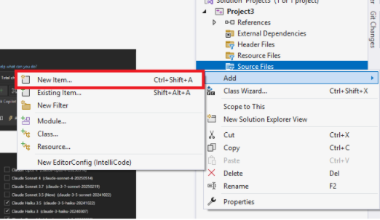
- Create a console application to display “Hello, World!”, you may use the source code provided in the lecture.

- Write a program that opens and processes the data file provided on CANVAS (W2_ExerciseData.csv).
The file contains data in a simple spreadsheet format that separates two numbers by a comma ‘,’. Currently the file contains two columns (Time, Value). Create a new file with an additional column with values you calculated (Time, Value, Square) where the ‘Square’ column should have the square of the value.
(Excel opens CSV files so you can use it to check and visualise your results)

Hint: use the comma as a third argument of “getline” function (see L2D3) and “stod” to convert the string into double. Or alternative use stringstreams.

- Use a repetition structure to automate reading the lines from the file. Consider what the difference is between using a for loop and a while loop.

- Modify the code so that it uses functions instead of running sequentially. Think of what functions can be defined and define them.

